Cody Kime
Professor Amiruzzaman
CSC 496 Independent Study
6/25/2024
Classification, Clustering and Neural Networks
Introduction
Before discussing classification and clustering, the topic of Supervised and Unsupervised methods must be introduced, which are the two basic approaches used to train machine learning models. Supervised methods map an input to an output using a series of functions using labeled data. For example, we may input data that is somebody’s height that the supervised method uses to output a prediction of their respective shoe size using a series of algorithms. Supervised learning can be used for things like spam filters, image recognition, etc., and can be separated into two categories: classification and regression.
Unsupervised methods on the other hand are used to discover the underlying structure of data and do not require input-to-output mappings, instead they create patterns from input data without references to labeled outcomes (Pykes, 2023). Unsupervised learning typically handles large volumes of data without the supervision of somebody (Hence the name unsupervised learning). Unsupervised learning is great for things like anomaly detection, social media analysis, etc. (Altexsoft, 2021), and can be used for three main tasks: clustering, association, and dimensionality reduction (Delua, 2024).
Classification
As previously mentioned, classification is a sub-category of the supervised machine learning model. Classification differs from regression in that classification uses algorithms to accurately assign test data into specific categories, while regression has the algorithm understand the relationship between the variables (Delua, 2024). Classification involves the model learning a function that maps an input to output based on input-output pairs and is also defined by its target variable being discrete rather than continuous. An example of a classification learning method could be a decision tree. The decision tree operates in a flow like state, starting at the root then moving down the tree according to the input. In the following example we can observe a basic decision tree that could be used to predict the weather.
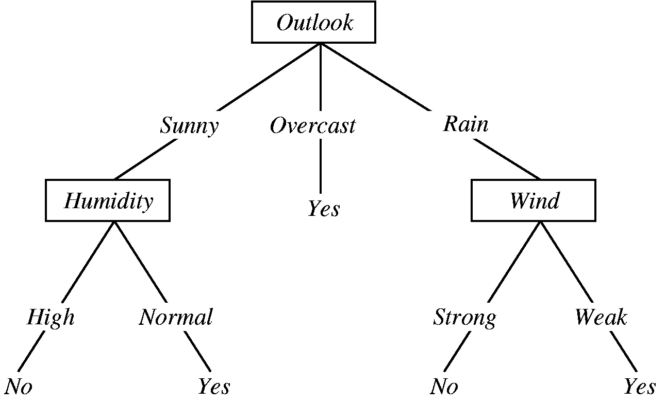
Figure 1 (Yadav, 2019)
Classification consists of four main tasks which include binary, multi-class, multi-label, and imbalanced classifications (Keita, 2022). In binary classification, training data is labeled in a binary format by classifying input data into two mutually exclusive categories. Multi-class classification involves having two or more class labels and then the model’s job is to predict which class it belongs to according to the input data. Multi-label classification is defined by how it predicts 0 or more classes for each input example. Finally, imbalanced classification considers the imbalance of the distribution in each class (Keita, 2022). Different types of classification models include Support Vector Machine, Naive Bayes, etc.
Clustering
Clustering is a sub-category of the unsupervised machine learning model. This technique is typically used to group unlabeled data based on the similarities or differences. (Pykes, 2023) Clustering is useful because the model can learn by grouping similar data points into larger datasets without worrying about specific outcomes. In the following graphic, we can see an example of data points and then how the clustering technique interprets that data and proceeds to create groups (or clusters) then place those data points into the groups according to their relativity.

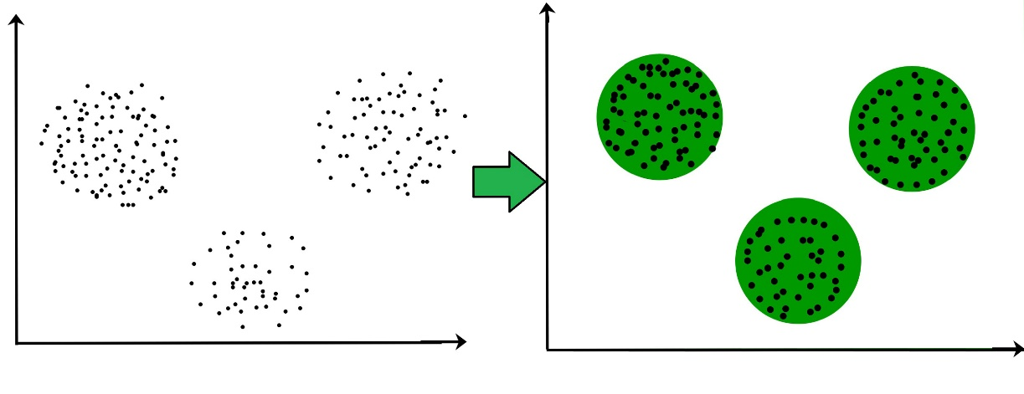
Figure 2 (Priy, 2018)
There are two types of clustering techniques which include hard clustering and soft clustering. Hard clustering consists of each data point belonging to a cluster completely or not; For example, if we had two clusters (Respectively cluster a and cluster b) every data point would have to go into a or b. While soft clustering evaluates the probability of a point being in a cluster. If we had the same cluster a and cluster b from the last example, we would rather evaluate the probability of the data points belonging to both clusters for all data points (Priy, 2018). Clustering is great for categorizing great volumes of data in things like market and social network analysis.
The four common clustering methods that are used include Centroid-based, Density-based, Distribution-based and Hierarchical. Centroid-based Clustering is the most popular clustering method and is known for its ability to group data points according to its closeness by creating partitions to form clusters. In Centroid-based Clustering the datasets are separated into a predetermined, non-hierarchical number of clusters as we can observe in the following example.

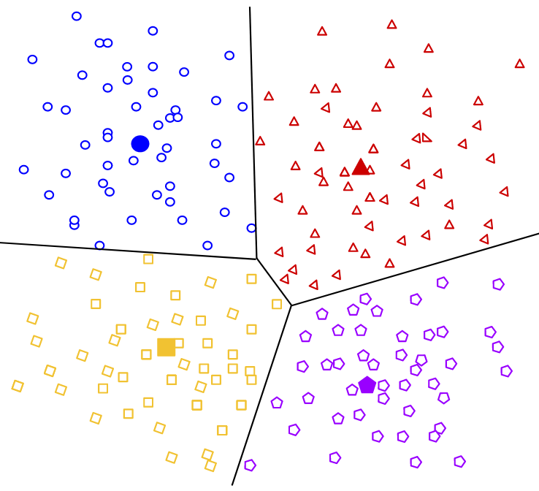
Figure 3 (Google, 2022)
Next, density-based clustering focuses on areas with a high density of data and creates arbitrary-shaped clusters. This clustering method does not force outliers into a cluster and data points that are close in a high-density area should always be put in the same cluster. If we observe the following example, we can see how a density-based clustering method may form clusters, leave out outliers, and ignore geometric shapes.
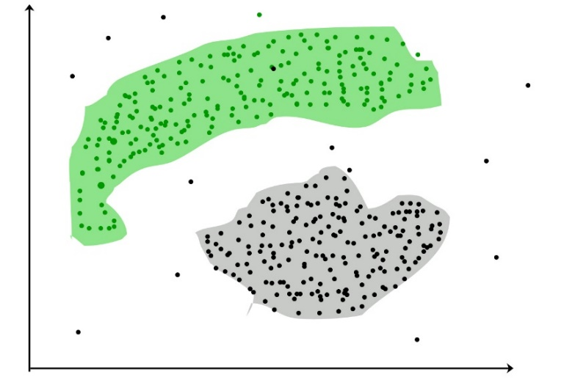
Figure 4 (GeeksforGeeks, 2018)
Distribution-based clustering utilizes predetermined distributions of clusters to find data for the model. The clustering of the density function is used to locate the clusters for a given model (Kurre, 2023). As distance from the distribution's center increases, the probability that a point belongs to the distribution decreases (Google, 2022). An interesting note about distribution-based clustering is that the distribution clusters can begin to overlap with each other which we can see with blue and yellow distribution clusters in the following example.
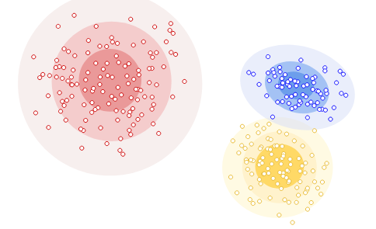
Figure 5 (Google, 2022)
Finally, Hierarchical clustering creates tiers of clusters that can exist within each other that can also be interpreted as a tree. In this clustering method, a cluster can contain a data point or another cluster. For example, in the following figure it can be observed how a hierarchical clustering method could organize data according to their hierarchy.
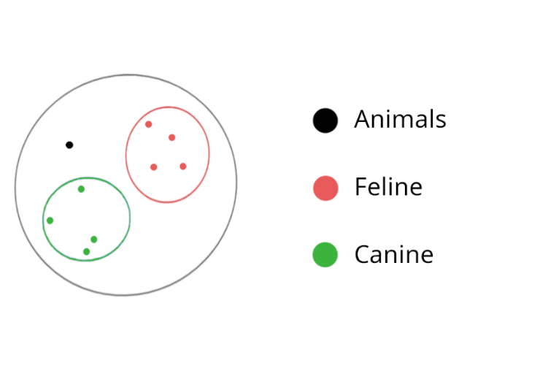
Figure 6
In this example we can determine the hierarchy of the clusters; A data point may be inside the canine cluster, indicating that it is a canine but also an animal. Whereas the black data point indicates that it is an animal but is not a canine or a feline since it is outside of those clusters.
Neural Networks
Finally, a Neural Network is a system or hardware designed to operate like a human brain by using a deep learning process to adapt by learning from mistakes and continuously improving. Neural Networks have become common as we use it for things like GPS, translating text, or using voice activated assistants like Siri or Alexa. Neural networks utilize different layers which include input, hidden, and output layers. The input layer handles the input data and gives it to the first hidden layer. There can be multiple hidden layers, and each layer is used to do any range of calculations and feature extraction. (Simplilearn, 2024) Lastly, the output layer will give our result. Each node of a previous layer connects to each node of the proceeding layer, creating complexity very quickly with the addition of each hidden layer. In the following example we can see the fundamental structure of how a neural network may work.
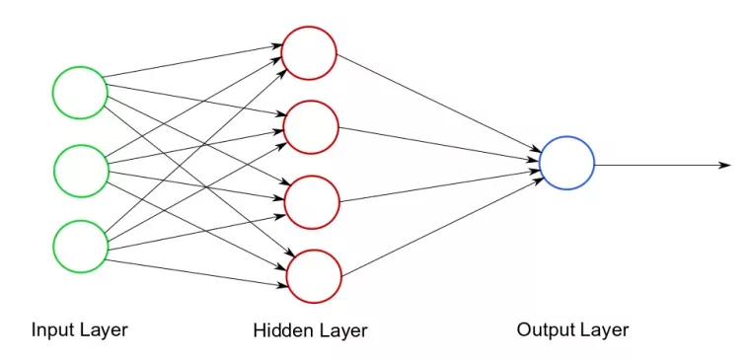
Figure 7 (Mazurek, 2020)
There are also different types of neural networks that are used for different purposes that include Feed-forward, Radial Basis Functions, Kohonen Self-organizing, Recurrent, Convolution, and Modular neural networks. Feed-forward is the simplest neural network. It’s fast to use but slow to learn since the data travels from input to output in one direction. Radial Basis Functions classifies and groups data points according to their distance from a predetermined center point. Radial Basis Functions neural network models are known to be used for power restoration systems. In a Kohonen Self-organizing neural network model, Vectors of random input are input to a discrete map comprised of neurons (Vectors are also called dimensions or planes) (Simplilearn, 2024). This neural network model is common for things like medical analysis.
Next, Recurrent neural networks use the output for a new input since it has hidden layers save their output to be used for future predictions. Text-to-speech conversion applications commonly utilize the Kohonen Self-organizing neural network model. Convolution neural networks are used to partition data into parts in order for the model to recognize data in parts. This type of neural network is commonly used for things such as facial recognition. Finally, Modular neural networks are intended to utilize multiple neural networks to work together to reach an output. (Mazurek, 2022)
Sources
Pykes, K. (2023, September 12). Classification vs Clustering in Machine Learning: A Comprehensive Guide. DataCamp.
https://www.datacamp.com/blog/classification-vs-clustering-in-machine-learning

Keita, Z. (2022, September). Classification in Machine Learning: An Introduction. DataCamp.
https://www.datacamp.com/blog/classification-machine-learning

Priy, S. (2018, February 9). Clustering in Machine Learning. GeeksforGeeks.
https://www.geeksforgeeks.org/clustering-in-machine-learning

Fradkov, A. L. (2020). Early history of machine learning. IFAC-PapersOnLine, 53(2), 1385–1390.
https://www.sciencedirect.com/science/article/pii/S2405896320325027

Delua, J. (2024, May 13). Supervised vs. unsupervised learning: What’s the difference? IBM.
https://www.ibm.com/think/topics/supervised-vs-unsupervised-learning

AltexSoft. (2021, April 14). Unsupervised Learning: Algorithms and Examples. AltexSoft.
https://www.altexsoft.com/blog/unsupervised-machine-learning

Yadav, P. (2019, September 23). Decision Tree in Machine Learning - Towards Data Science. Medium.
https://towardsdatascience.com/decision-tree-in-machine-learning-e380942a4c96
Google (2022, July 18). Clustering Algorithms. (n.d.). Google for Developers.
https://developers.google.com/machine-learning/clustering/clustering-algorithms

Kurre, A. (2023, August 2). Types of Clustering Algorithms in Machine Learning - Pickl.AI. Pickl.AI. https://www.pickl.ai/blog/types-of-clustering-algorithms/

Simplilearn. (2024, February 15). An ultimate tutorial to neural networks. Simplilearn
https://www.simplilearn.com/tutorials/deep-learning-tutorial/neural-network

Mazurek, M. (2020, December 21). Simple neural network – ImpiCode
https://impicode.com/blog/simple-neural-network/

Amazon - What is a Neural Network - AWS. (n.d.). Amazon Web Services, Inc.
https://aws.amazon.com/what-is/neural-network/

